

Mohammad Ali Jinnah University

Chartered by Government of Sindh - Recognized by HEC

**Lab Assignment 1**

**Name:** Muhamad Fahad

**Id:** FA19-BSSE-0014

**Subject:** Data Structures and Algorithms Lab (CS 2511)

**Lab Title:** Linear Search

**Section:** AM

**Teacher:** MUHAMMAD MUBASHIR KHAN

**Date:** Friday, October 16, 2020

**Lab Tasks**

1. **Write a program to search a key linearly?**

**Code:**

import java.util.Arrays;  
public class Task1 {  
 public static void main(String[] args) {  
 System.*out*.println("1) Write a program to search a key linearly?\n");  
 // Varabile  
 int Array[] = {8,9,6,4,10,5};  
 int key = 5;  
 boolean flag = true;  
 int i;  
  
 System.*out*.println("The Array is: "+ Arrays.*toString*(Array));  
 System.*out*.println("The Key is: "+key+"\n");  
  
 for(i = 0; i< Array.length; i++){  
 if(key == Array[i]){  
 flag = true;  
 break;  
 }  
 }  
  
 System.*out*.println("The key"+(!flag ? " not found":" found at index: "+i)+" in the array");  
 }  
}

**Output:**

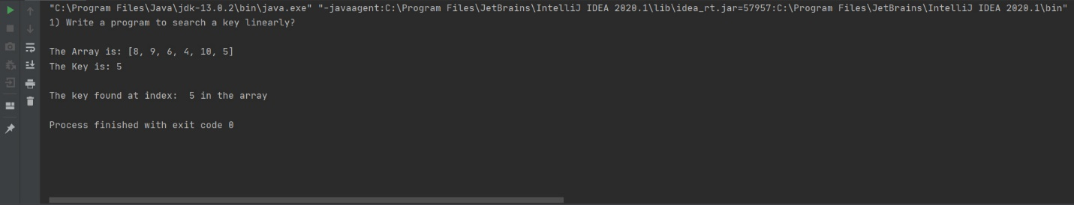

1. **Write a program to find maximum & minimum number from an array?**

**Code:**

import java.util.Arrays;  
import java.util.Scanner;  
  
public class Ex2 {  
 public static void main(String[] args) {  
 System.*out*.println("2) Write a program to find maximum & minimum number from an array ?\n");  
  
 int i;  
 int max,min;  
 Scanner myObj = new Scanner(System.*in*);  
  
 System.*out*.print("Enter the length of the array: ");  
 int arrayLength = myObj.nextInt();  
  
 int Array[] = new int[arrayLength];  
  
 for(i = 0; i < arrayLength; i++){  
 System.*out*.print("Enter the value of "+i+" index: ");  
 Array[i] = myObj.nextInt();  
 }  
  
 System.*out*.println("\nThe Array is: "+ Arrays.*toString*(Array));  
  
  
 max = Array[0];  
 min = Array[0];  
  
 for(i = 0; i< arrayLength; i++){  
 if(Array[max] < Array[i]){  
 max = i;  
 }  
 else if(Array[min] > Array[i]){  
 min = i;  
 }  
 }  
  
 System.*out*.println("\nThe max Value is "+Array[max]+" at index: "+max+" in the array");  
 System.*out*.println("The min Value is "+Array[min]+" at index: "+min+" in the array");  
  
  
 }  
}

**Output:**

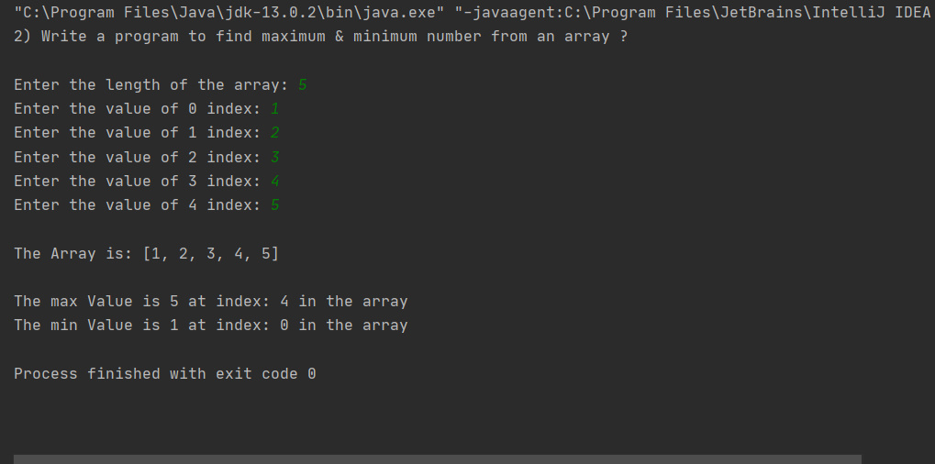

1. **Write a program to find the occurrence of the key in the array?**

**Code:**

import java.util.Arrays;  
import java.util.Scanner;  
  
public class Task3 {  
 public static void main(String[] args) {  
 System.*out*.println("3)\tWrite a program to find the occurrence of the key in the array?\n");  
  
 boolean flag = true;  
 int i,count=0;  
  
 Scanner myObj = new Scanner(System.*in*);  
  
 System.*out*.print("Enter the length of the array: ");  
 int arrayLength = myObj.nextInt();  
  
 int Array[] = new int[arrayLength];  
  
 for(i = 0; i < arrayLength; i++){  
 System.*out*.print("Enter the value of "+i+" index: ");  
 Array[i] = myObj.nextInt();  
 }  
  
 System.*out*.print("Enter the value you wants to Search: ");  
 int key = myObj.nextInt();  
  
 System.*out*.println("\nThe Array is: "+ Arrays.*toString*(Array));  
  
 for(i = 0; i< Array.length; i++){  
 if(key == Array[i]){  
 count++;  
 flag = true;  
 }  
 }  
  
 System.*out*.println("The key "+(!flag ? "not": count+" time ")+"occurrence in the array");  
  
  
  
 }  
}

**Output:**

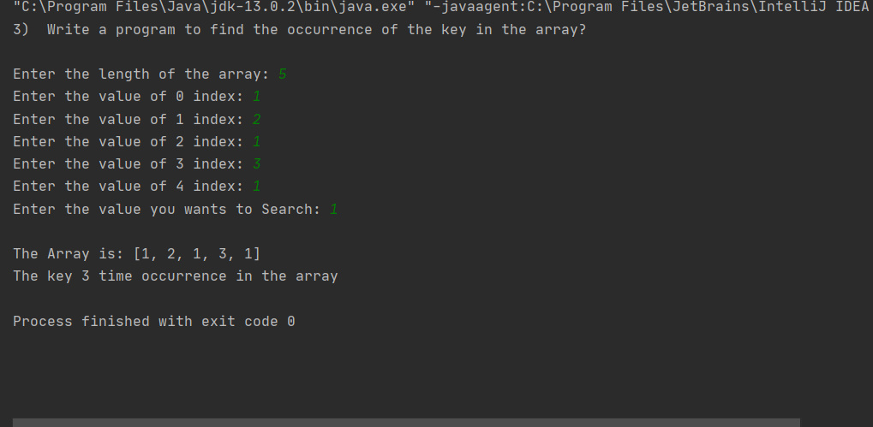

1. **Write a program to calculate the sum of the elements on an array?**

**Code:**

import java.util.Scanner;  
public class Task4 {  
 public static void main(String[] args) {  
 System.*out*.println("4)\tWrite a program to calculate the sum of the elements on an array? \n");  
 int i;  
 int sum = 0;  
 Scanner myObj = new Scanner(System.*in*);  
 System.*out*.print("Enter the length of the array: ");  
 int arrayLength = myObj.nextInt();  
 int arr2[] = new int[arrayLength];  
  
 for(i = 0; i<arrayLength;i++){  
 System.*out*.print("Enter the value of "+i+" index: ");  
 arr2[i] = myObj.nextInt();  
 }  
  
 for(i = 0; i< arrayLength; i++){  
 sum += arr2[i];  
 }  
  
 System.*out*.println("The Sum of all the values is "+sum+" in the array");  
  
  
 }  
}

**Output:**

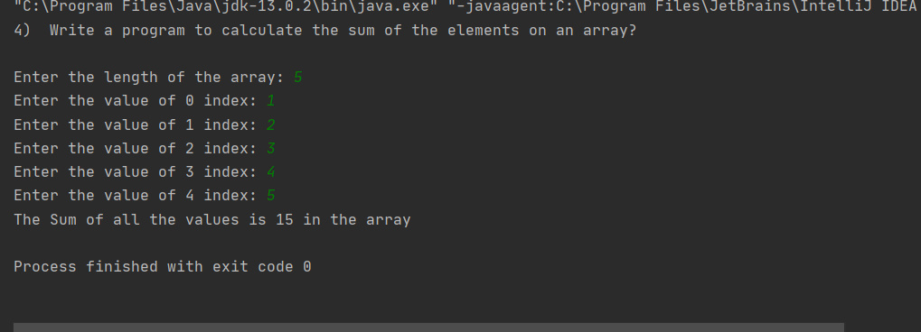

1. **Write a program in which user will input the array and the key for searching?**

**Code:**

import java.util.Arrays;  
import java.util.Scanner;  
  
public class Task5 {  
 public static void main(String[] args) {  
 int i, key;  
 boolean flag = false;  
  
 System.*out*.print("5) Write a program in which user will input the array and the key for searching?\n");  
  
 Scanner myObj = new Scanner(System.*in*);  
 System.*out*.print("Enter the length of the array: ");  
 int arrayLength = myObj.nextInt();  
 int Array[] = new int[arrayLength];  
  
 for(i = 0; i<arrayLength;i++){  
 System.*out*.print("Enter the value of "+i+" index: ");  
 Array[i] = myObj.nextInt();  
 }  
  
 System.*out*.print("Enter the value you wants to Search: ");  
 key = myObj.nextInt();  
  
  
 System.*out*.println("\nThe Array is: "+ Arrays.*toString*(Array));  
 System.*out*.println("Key to found: "+key+"\n");  
  
 for(i = 0; i< arrayLength; i++){  
 if(key == Array[i]){  
 flag = true;  
 break;  
 }  
 }  
  
 System.*out*.println("The key"+(!flag ? " not found":" found at index: "+i)+" in the array");  
  
 }  
}

**Output:**

